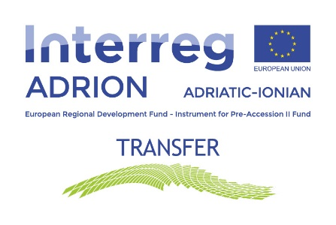

TRANSFER Project
Expression of Interest
to participate in a study visit to one of the archaeological parks in Italy, Albania, Slovenia, Greece or Croatia during the Summer 2022!
Deadline 30 April 2022
Fill in the form in English
- Personal- and contact details
First name
Last name
Complete address (street, street number, postal code, city, country)
City of residence
Country of residence
Nationality
Place of birth
Date of birth
Phone number including international prefix
Email

- School / University
Name of school/university
City
Country
Course of study

- Archaeological Parks
Indicate if you have any preferences of where to carry out the study visit  (you can indicate more than one option) | □ Urbs-Salvia – Italy
 | □ Antigonea – Albania
 | □ Poetovio – Slovenia
 | □ Dodona – Greece
 | □ Bribirska Glavica / Velika Mrdakovicaj – Croatia
 | □ Mirine-Fulfinum – Croatia

- Period
Please indicate when you would be available to carry out the study visit  (you can indicate more than one option) | □ July
 | □ August
 | □ September

- People with disadvantages
If you compete for one of the study visits reserved for people with disadvantages, indicate which disadvantage you have (tick the relevant box in the left column), complete the text in the right column and attach any proof requested

□ Person with physical disability | If yes, indicate type of disability (and attach certificate):  ___________________
□ Person coming from a low-income  household | If yes, attach a proof of receiving less income than average defined by the country of resident
□ Person immigrated less than 3 years  ago to one of the project countries*  (i.e., after 30 April 2019).  *Italy, Albania, Slovenia, Serbia, Greece, Croatia | If yes, indicate entrance date (date of registration in the city of residence):  ____________________
Indicate from which city/country you immigrated:

____________________

I hereby certify that I have immigrated less than 3 years ago, on the (fill in date DD/MM/YY) from (fill in the name of the city and country) to (fill in the name of the city and country where you live today)

SIGNATURE:

________________________

- Motivations
Please describe your motivations for applying to participate in a study visit

- Documents to be attached to this Expression of Interest form:
- Curriculum Vitae in English (use attached EUROPASS CV Form)
- Copy (double-sided) of valid Identity document (passport or ID card)
- Document showing city of residence if not indicated on the ID document
- Copy of school or university registration /certificate
- Certificate of physical disability (only if you are competing for one of the study visits that are reserved for young people with disadvantages)
- Certificate proofing you come from a low-income household (only if you are competing for one of the study visits that are reserved for people with disadvantages)
- Certificate proofing good command of English (Optional).

_____________________________________________________________________________________

I authorize the processing of my personal data pursuant to art. 13 GDPR (EU Regulation 2016/679) for the purpose of the selection of participants and of the implementation of study visits.
I declare that I have read the Call for Expression of Interest.
I do hereby declare that all the information provided is true and completed to the best of my knowledge.

Signature: ______________________________________________

First name (in block letters) ___________________ Last name (in block letters): ______________

Place: ___________________________________ Date: _________________________________

